 



Database Programming with SQL 13-3: Modifying a Table

Practice Activities

# Objectives

* Explain why it is important to be able to modify a table
* Explain and provide an example for each of the DDL statements—ALTER, DROP, RENAME, and TRUNCATE—and the effect each has on tables and columns
* Construct a query and execute the ALTER TABLE commands ADD, MODIFY, and DROP
* Explain and perform a FLASHBACK QUERY on a table
* Explain and perform FLASHBACK table operations
* Track the changes to data over a period of time
* Explain the rationale for using TRUNCATE versus DELETE for tables
* Add a comment to a table using the COMMENT ON TABLE command
* Name the changes that can and cannot be made to modify a column
* Explain when and why the SET UNUSED statement is advantageous

# Try It / Solve It

Before beginning the practice exercises, execute a DESCRIBE for each of the following tables: o_employees, o_departments and o_jobs. These tables will be used in the exercises. If they do not exist in your account, create them as follows:

1. **Create the three o_tables – jobs, employees, and departments – using the syntax: CREATE TABLE o_jobs AS (SELECT * FROM jobs);**

**CREATE TABLE o_employees AS (SELECT * FROM employees); CREATE TABLE o_departments AS (SELECT * FROM departments);**

1. **Add the Human Resources job to the jobs table:**

**INSERT INTO o_jobs (job_id, job_title, min_salary, max_salary) VALUES('HR_MAN', 'Human Resources Manager', 4500, 5500);**

1. **Add the three new employees to the employees table:**

**INSERT INTO o_employees (employee_id, first_name, last_name, email, hire_date, job_id)**

**VALUES(210, 'Ramon', 'Sanchez', 'RSANCHEZ', SYSDATE, 'HR_MAN');**

1. **Add Human Resources to the departments table:**

**INSERT INTO o_departments(department_id, department_name) VALUES (210,'Human Resources');**

You will need to know which columns do not allow null values.

1. Why is it important to be able to modify a table?

Может изменяться структура данных, как и в процессе разработку могут допускаться ошибки

1. CREATE a table called Artists.
   1. Add the following to the table:
      * artist ID
      * first name
      * last name
      * band name
      * email
      * hourly rate
      * song ID from d_songs table

CREATE TABLE artists

(artist_id NUMBER(5,0),

first_name VARCHAR2(25) CONSTRAINT ait_first_name_nn NOT NULL ENABLE,

last_name VARCHAR2(30) CONSTRAINT ait_last_name_nn NOT NULL ENABLE,

band_name VARCHAR2(30),

email VARCHAR2(75) CONSTRAINT ait_email_nn NOT NULL ENABLE,

hr_rate NUMBER(8,2) CONSTRAINT ait_hr_rate_nn NOT NULL ENABLE,

song_id NUMBER(5,0) CONSTRAINT ait_song_id_nn NOT NULL ENABLE,

CONSTRAINT ait_id_pk PRIMARY KEY (artist_id)

);

* 1. INSERT one artist from the d_songs table.

INSERT INTO artists (artist_id, first_name, last_name, band_name, email, hr_rate, song_id)

SELECT 1 AS artist_id,

CASE

WHEN artist IS NULL THEN 'first name unknown'

WHEN INSTR(artist,' ') = 0 THEN artist

ELSE SUBSTR(artist,1,INSTR(artist,' ') -1)

END

AS first_name,

CASE

WHEN artist IS NULL THEN 'last name unknown'

WHEN INSTR(artist,' ') = 0 THEN artist

ELSE SUBSTR(artist,INSTR(artist,' '),LENGTH(artist))

END

AS last_name,

artist as band_name,

NULL as email,

NULL as hr_rate,

id as song_id

FROM d_songs

WHERE ROWNUM =1 ;

SELECT * FROM artists;

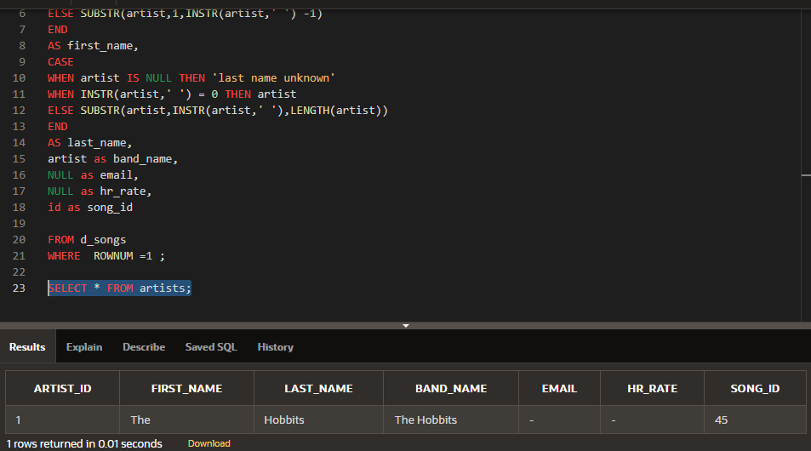

* 1. INSERT one artist of your own choosing; leave song_id blank.

ALTER TABLE artists

DROP CONSTRAINT ait_song_id_nn;

INSERT INTO artists (artist_id, first_name, last_name, band_name, email, hr_rate, song_id)

VALUES(2,'David','Gray','david''s band','some.email@somedomain.com','999999.99',NULL);

SELECT * FROM artists;

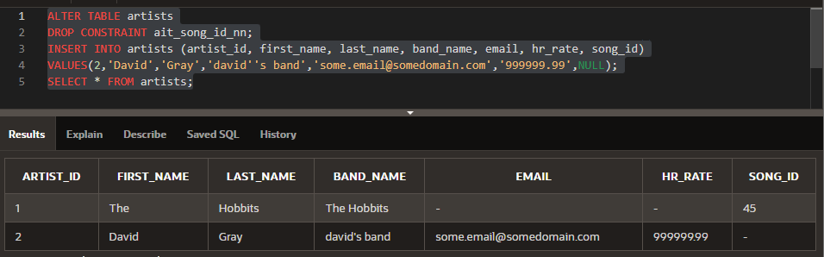

* 1. Give an example how each of the following may be used on the table that you have created:

1. ALTER TABLE
2. DROP TABLE

ALTER TABLE artists

ADD (specialty VARCHAR2(100), college VARCHAR2(100));

ALTER TABLE artists

MODIFY (specialty VARCHAR2(99), college VARCHAR2(98));

ALTER TABLE artists

DROP COLUMN specialty;

ALTER TABLE artists

RENAME COLUMN college to university;

ALTER TABLE artists

RENAME TO artists_new_name;

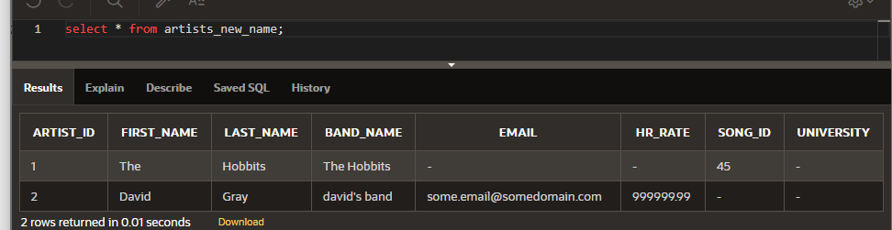

1. RENAME TABLE

RENAME artists_new_name TO artists_new2;

1. TRUNCATE

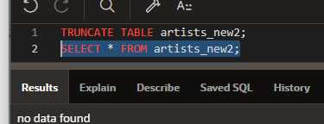

1. COMMENT ON TABLE

COMMENT ON TABLE artists_new2 IS 'MyComment';

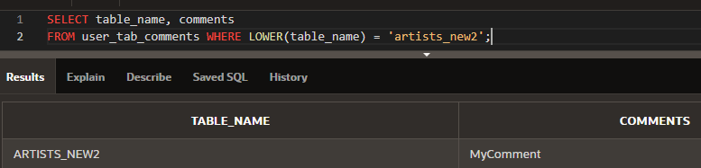

1. In your o_employees table, enter a new column called “Termination.” The datatype for the new column should be VARCHAR2. Set the DEFAULT for this column as SYSDATE to appear as character data in the format: February 20th, 2003.

ALTER TABLE o_employees

ADD ("Termination" VARCHAR2(100) DEFAULT TO_CHAR(SYSDATE,'Month ddth, YYYY') );

INSERT INTO o_employees (employee_id, first_name, last_name, email, hire_date, job_id)

VALUES(213, 'Ramon213', 'Sanchez213', 'RSANCHEZ213', SYSDATE, 'HR_MAN');

SELECT "Termination" FROM o_employees WHERE employee_id = 213;

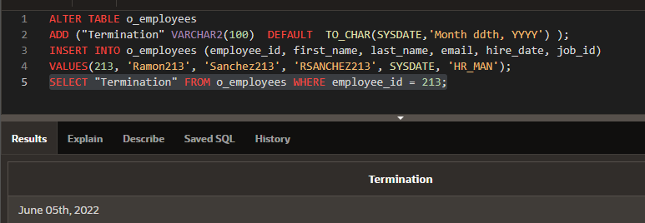

1. Create a new column in the o_employees table called start_date. Use the TIMESTAMP WITH LOCAL TIME ZONE as the datatype.

ALTER TABLE o_employees

ADD (start_date TIMESTAMP WITH LOCAL TIME ZONE);

Select * from o_employees

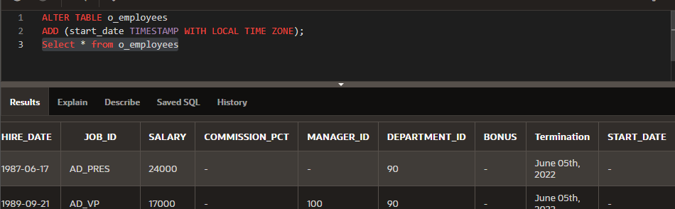

1. Truncate the o_jobs table. Then do a SELECT * statement. Are the columns still there? Is the data still there?

DESCRIBE o_jobs;

SELECT * FROM o_jobs;

TRUNCATE TABLE o_jobs;

DESCRIBE o_jobs;

SELECT * FROM o_jobs;

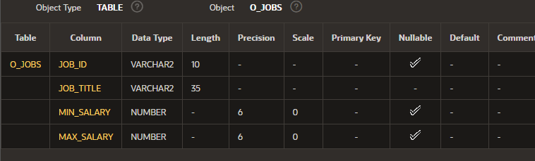

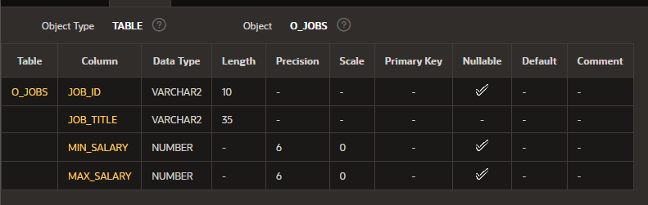

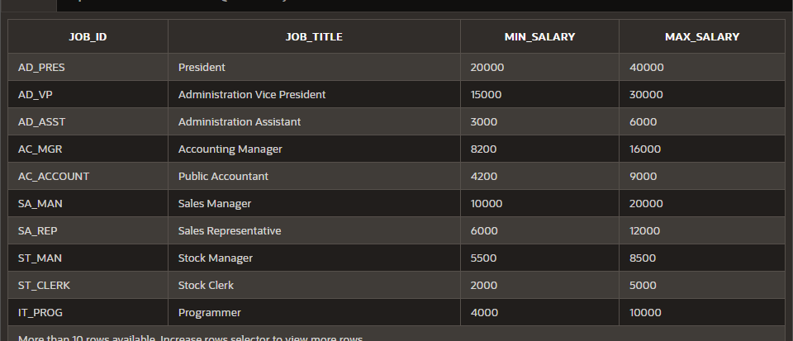

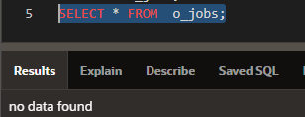

Вся информация стерлась

1. What is the distinction between TRUNCATE, DELETE, and DROP for tables?

DROP TABLE Удаляет таблицы вместе с данными и индексами (возможно, это можно будет восстановить)

TRUNCATE TABLE - очищает все данные, но не удаляет таблицу, освобождает место для хранения

DELETE TABLE – удаляет строки, по типу select, то есть можно использовать с условием, но не освобождает место для хранения

1. List the changes that can and cannot be made to a column.

**1. Вновь созданный столбец всегда ставится последним. Но select можно написать так, чтобы он возвращался желаемым образом, так что никаких проблем.**

**0. Добавление нового столбца в таблицу всегда будет присваивать значение null новому полю уже существующей строки, даже если новому столбцу присвоено значение по умолчанию.**

**1. Я могу увеличить точность числового столбца.**

**2. Можно увеличить длину столбца символов.**

**3. Я могу уменьшить точность числового столбца, если: он до сих пор содержит только нули или в таблице нет строки. В противном случае я получу ORA-00940: недопустимая команда ALTER.**

**4. Длина varchar2 может быть уменьшена до наибольшего значения, присутствующего в данный момент во всех строках.**

**5. Тип данных можно полностью изменить, если все значения в этом столбце равны нулю.**

**6. char может стать varchar2, если столбец содержит нули или заданный размер не меньше, чем любое существующее поле для этого столбца.**

**6. varchar2 может стать символом, если столбец содержит нули или заданный размер не меньше, чем любое существующее поле для этого столбца.**

**7. Изменение значения по умолчанию действует только для новых вставок, а не для уже существующих строк.**

**8. Столбец, содержащий значения, может быть удален, если он не указан как внешний ключ в других таблицах. Кроме того, значения данных в нем не восстанавливаются после удаления столбца.**

**9. Я могу удалить только один столбец за раз. Кроме того, должен остаться хотя бы один столбец, я не могу удалить последний столбец.**

**10. Поскольку удаление столбца может занять некоторое время, оно изменяет каждую строку перед удалением, я могу использовать команду SET UNUSED в качестве замены для практических целей и DROP UNUSED позже.**

**11. Я могу переименовать столбец, если захочу.**

1. Add the following comment to the o_jobs table: "New job description added"

View the data dictionary to view your comments.

COMMENT ON TABLE o_jobs IS 'New job description added';

SELECT table_name, comments

FROM user_tab_comments WHERE LOWER(table_name) = 'o_jobs';

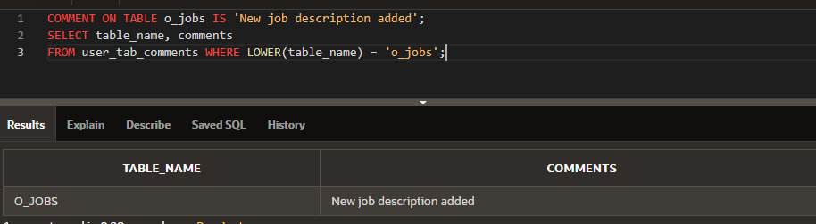

1. -Rename the o_jobs table to o_job_description.

ALTER TABLE o_jobs

RENAME TO o_job_description;

RENAME o_job_description TO o_job_description2

1. F_staffs table exercises:
   1. Create a copy of the f_staffs table called copy_f_staffs and use this copy table for the remaining labs in this lesson

. CREATE TABLE copy_f_staffs1

AS ( SELECT * FROM f_staffs);

DESCRIBE f_staffs;

DESCRIBE copy_f_staffs1;

SELECT * FROM f_staffs;

SELECT * FROM copy_f_staffs1;

* 1. Describe the new table to make sure it exists.

DESC copy_f_staffs1;

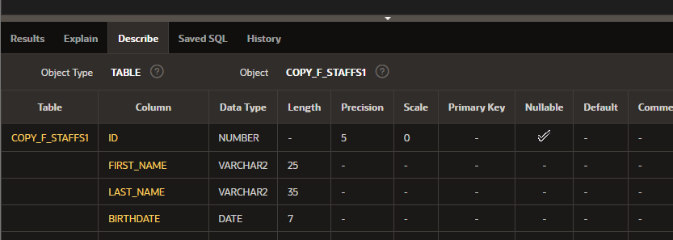

* 1. Drop the table.

DROP TABLE copy_f_staffs1;

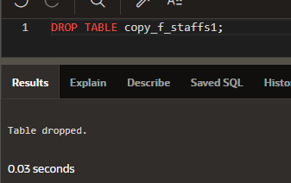

* 1. Try to select from the table.

SELECT * FROM copy_f_staffs1;

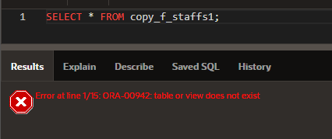

* 1. Investigate your recyclebin to see where the table went.

DESCRIBE user_recyclebin ;

Please note droptime is varchar2 here.

SELECT * FROM

(SELECT * FROM user_recyclebin ORDER BY droptime DESC)

WHERE ROWNUM <= 100;

SELECT object_name,droptime FROM user_recyclebin WHERE LOWER(original_name) = 'copy_f_staffs1';

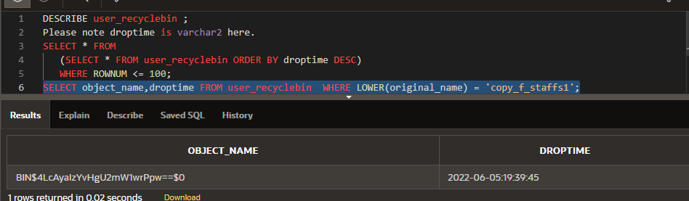

* 1. Try to select from the dropped table by using the value stored in the OBJECT_NAME column. You will need to copy and paste the name as it is exactly, and enclose the new name in “ “ (double quotes). So if the dropped name returned to you is BIN$Q+x1nJdcUnngQESYELVIdQ==$0, you need to write a query that refers to “BIN$Q+x1nJdcUnngQESYELVIdQ==$0”.

SELECT * FROM "BIN$4LcAyaIzYvHgU2mW1wrPpw==$0";

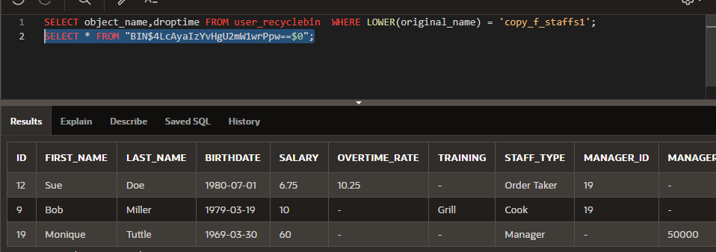

* 1. Undrop the table.

FLASHBACK TABLE copy_f_staffs1 TO BEFORE DROP;

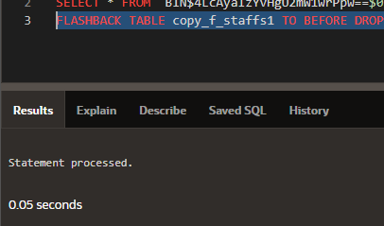

* 1. Describe the table.

DESCRIBE copy_f_staffs1;

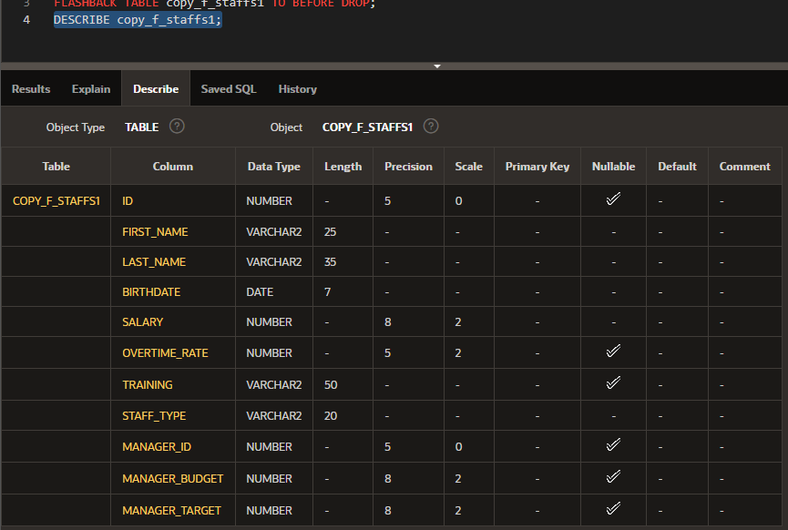

1. Still working with the copy_f_staffs table, perform an update on the table.
   1. Issue a select statement to see all rows and all columns from the copy_f_staffs table;

SELECT * FROM copy_f_staffs1;

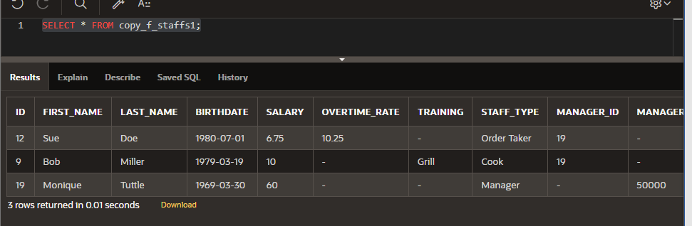

* 1. Change the salary for Sue Doe to 12 and commit the change.

UPDATE copy_f_staffs1

SET salary = 12

WHERE first_name = 'Sue' AND last_name = 'Doe';

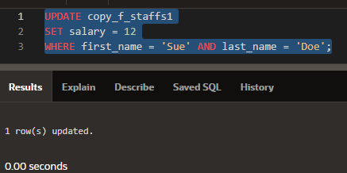

* 1. Issue a select statement to see all rows and all columns from the copy_f_staffs table;

SELECT * FROM copy_f_staffs1;

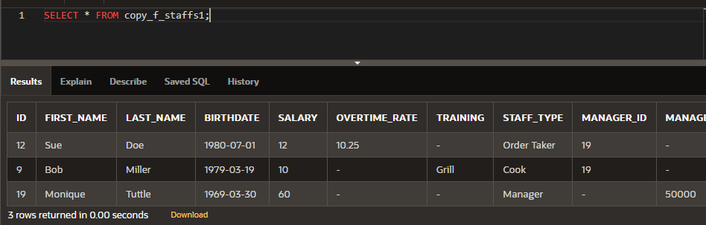

* 1. For Sue Doe, update the salary to 2 and commit the change.

UPDATE copy_f_staffs1

SET salary = 2

WHERE first_name = 'Sue' AND last_name = 'Doe';

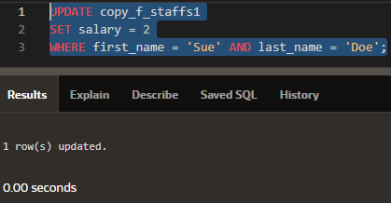

* 1. Issue a select statement to see all rows and all columns from the copy_f_staffs table;

SELECT * FROM copy_f_staffs1;

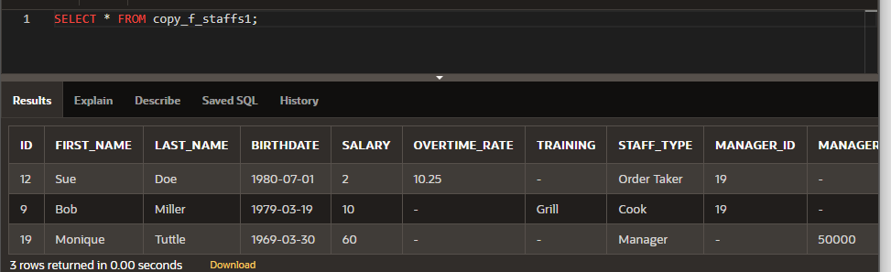

* 1. Now, issue a FLASHBACK QUERY statement against the copy_f_staffs table, so you can see all the changes made.

SELECT versions_operation, versions_starttime, versions_endtime, id, first_name, last_name, birthdate, salary,overtime_rate,training,staff_type,manager_id, manager_budget,manager_target

FROM copy_f_staffs1

VERSIONS BETWEEN SCN MINVALUE AND MAXVALUE

WHERE id = 12;

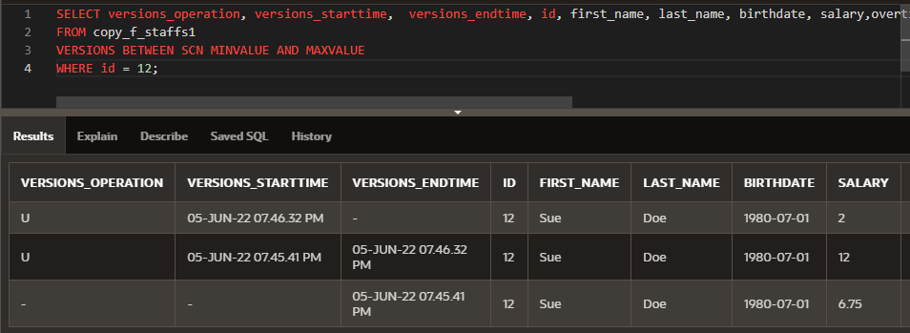

* 1. Investigate the result of f), and find the original salary and update the copy_f_staffs table salary column for Sue Doe back to her original salary.

UPDATE copy_f_staffs

SET salary = (SELECT salary

FROM copy_f_staffs

VERSIONS BETWEEN SCN MINVALUE AND MAXVALUE

WHERE first_name = 'Sue' AND last_name = 'Doe' AND versions_operation IS NULL AND versions_starttime IS NULL)

WHERE first_name = 'Sue' AND last_name = 'Doe';

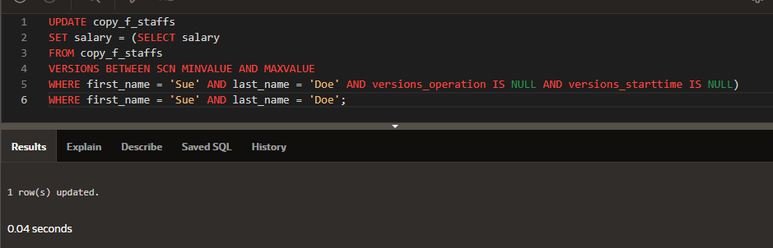

SELECT * FROM copy_f_staffs1;

SELECT versions_operation, versions_starttime, versions_endtime, id, first_name, last_name, birthdate, salary,overtime_rate,training,staff_type,manager_id, manager_budget,manager_target

FROM copy_f_staffs1

VERSIONS BETWEEN SCN MINVALUE AND MAXVALUE

WHERE id = 12;

